Dear Parent/Guardian,

RE: Clinic referral for an initial ADHD assessment – Secondary School age child

Your son/daughter has been referred to CAMHS for an ADHD assessment. We need to collect some background information as part of the assessment process. The ADHD assessment consists of the following:-

- Collection of information through questionnaires sent to home and child/young person’s school.
- Clinic appointment of up to 1 hour where the doctor or clinician will see your child and collect additional information from both you and your child.
- In some cases, a school observation may be needed to help with the initial assessment or to help clarify further information. The doctor or clinician will let you know if your child requires a school observation.

We would be grateful if you could kindly complete the following questionnaires:-

- Child and Family information form (including Intellectual Difficulties Screening Questionnaire and SNAP-IV)
- Weiss Functional Impairment Rating Scale and SDQ

Please include any previous end of term school reports from nursery/primary school and any Educational Psychologist reports you may have. Original copies will be returned to you.

Please kindly return the forms in the envelope provided.

We will also send the following forms for you to pass to your child’s Class Teacher/SENco/Head Teacher for completion:-

- Teacher (school) feedback form (includes ADHD Teacher information questionnaire SNAP-IV)

Many thanks,

Single Point of Access (SPA)

CHILD AND FAMILY INFORMATION FORM (PRE-CLINIC)

Childs Name: Date of birth:

Gender: Male/Female

Child/young person’s address:

- PERSON(S) WITH PARENTAL RESPONSIBILITY

Name: Relationship to child/young person:

Address:

Telephone number:

Name: Relationship to child/young person:

Address:

Telephone number:

Who does child/young person live with?

- FAMILY STRUCTURE (including details of full or half siblings)

NAME | AGE | GENDER | RELATIONSHIP TO CHILD/YOUNG PERSON

- CONCERNS ABOUT CHILD/YOUNG PERSON

- What are your concerns about the child/young person?

- What are the child/young persons’ strengths?

- What would you like us to address at the consultation?

- Do you have any specific questions? Please list

- SCHOOL HISTORY

- Child/young persons’ school (including address) and year

- Teacher/Form tutor’s name

- Are you happy for us to contact the child/young person’s school
for information? YES / NO

 | NO | YES | Please describe
Does the child/young person have learning problems?
Does the child/young person have behavior problems in school?
Does the child/young person have difficulties with peer relationships (friendships) in school?
Is the child/young person having any special help in school?
Has the child/young person ever been held back a grade?
Other school problems?

- MEDICAL HISTORY

- Child/young person’s GP details

- Does the child/young person have any medical problems? YES / NO

If Yes, please provide details:

- Does the child/young person take any medication now? YES / NO

If Yes, please provide details:

- Has the child/young person had previous hospital admissions,
accidents, operations or severe illnesses YES / NO

If Yes, please describe

- Does the child/young person have any allergies? YES / NO

If yes, please describe

- PREGNANCY AND BIRTH HISTORY

- Was the child full term or preterm?

- If preterm, how many weeks was the child at birth?

- Do you still have the child’s ‘red book’ (Development record)? It may be helpful to look at this when answering the following questions.

Please indicate a response to the following questions
 | NO | YES | PLEASE DESCRIBE
Did child’s/young persons’ mother have any medical problems during the pregnancy?
Did child/young person’s mother smoke during this pregnancy? I yes, please state quantity
Did child/young person’s mother drink alcohol during this pregnancy? If yes, state quantity
Were there any problems during labour and delivery?

Did the child/young person require resuscitation at birth?

Did the child/young person require admission into the baby unit after birth?
What did the child/young person weigh at birth?

What was his/her head circumference at birth?

Was the child/young person difficult to care for as a baby?

- DEVELOPMENTAL HISTORY

 | NO | YES | PLEASE DESCRIBE
Did the child/young person have any delay in his/her early development?

Was there delay in walking alone?

Was there delay in speaking?

Was there delay being dry during the day/night?

Was there delay in reading?

Was there delay in writing?

Was there delay in dressing?

Any sleep difficulties?

- BEHAVIOUR HISTORY

 | NO | YES | PLEASE DESCRIBE
Is the child/young person overactive?

Does the child/young person have difficulty paying attention?
Does the child/young person have difficulty staying with one activity?
Does the child/young person get frustrated very easily?
Does the child/young person get upset easily by sudden changes to activities?
Does the child/young person have difficulties with relationships with others?
Does the child/young person respond to discipline?
Does the child/young person have any sleep difficulties now?
Does the child/young person have any tics?

- What are the parental concerns about behavior? How do you discipline the child/young person?

- Have you attended any parenting courses? YES / NO

If yes, please specify:

- FAMILY HISTORY

Does any close family member have the following conditions? If yes, please specify

 | YES | NO | PLEASE SPECIFY
Neurological disease (e.g. seizures, weakness)

Learning problems

ADHD

Autistic spectrum disorder

Development delay

Behavior problems

High blood pressure/heart disease/heart rhythm problems
Mental health problems

Sudden collapse/unexplained deaths in anyone under the age of 40 years

- CURRENT LIVING SITUATION

Please indicate if any of the following situations apply to the child/young person’s living conditions:

 | NO | YES | PLEASE DESCRIBE
Relationship/marital problems between child’s major caregivers
Problems with current living situation

Problems with siblings or other persons living at home
Violence in the home or neighborhood

Drug/alcohol problems in home or neighborhood

Other problems

- PLEASE WRITE DOWN ANYTHING ELSE YOU WOULD LIKE US TO KNOW:

- Forms completed by: Relationship to child:

- Date form completed:

Thank you for completing this information sheet

INTELLECTUAL DIFFICULTIES SCREENING QUESTIONNAIRE–SECONDARY SCHOOL

Child name: Male / Female

Date of Birth: Date of completion

Age at completion of questionnaire:

- Are there any concerns about your son/daughter’s learning? YES / NO

If yes, please answer the questions below relating to your child’s current school level

- Secondary school

 |  | NEVER | SOMETIMES | OFTEN
Reading | Can your son/daughter keep up with the reading demands expected in the school?
 | Can your son/daughter use the materials he reads to answer questions appropriately?
 | Does your son/daughter sometimes misread questions or instructions on the assignment?
Writing | Does your son/daughter have difficulties with providing the correct answers to questions?
 | Can your child write a report that covers all the information that the teachers require?
 | Does your son/daughter need help with organizing their thoughts before he/she can write it down on paper?
Maths | Does your child sometimes misread worded math’s problems?
 | Does your child understand the math’s problems being taught at school?
 | Does your son/daughter make careless errors when doing math’s calculations?
Organization skills | Does your son/daughter’s papers, notebooks and backpack get neatly packed and organized?
 | Is your son/daughter’s desk, wardrobe or room organised and tidy?
 | Does your son/daughter, lose, forget or misplace papers and other materials?
 | Does your son/daughter have difficulty organizing information when studying for tests or writing an exam?
Executive function | Is your son/daughter good at planning out how to do the class assignment?
 | Does your son/daughter get his/her work done on time?
 | Does your son/daughter hand in their homework on time?
If you have answered sometimes/often, please provide further details

- Does your son/daughter have any difficulties with their language and understanding?

If yes, please guide your son/daughter to answer the questions below

 |  | NEVER | SOMETIMES | OFTEN
Receptive language | When the teacher is speaking in class, do you sometimes have difficulty understanding or keeping up with what is being said?
 | Do you sometimes find that you misunderstand what people are saying and give the wrong answers or response?
 | When people are talking, do you find that you have to focus so hard on what they are saying that you sometimes still miss what is being said?
 | If your teacher is teaching during the lessons, do you sometimes not fully understand what is being said?
Expressive language | Do you sometimes have difficulty getting your thoughts together on the paper when you have to answer a question?
 | Do you sometimes struggle to find the right words to use when you are speaking at home, school or with your friends?
Please explain further if you have selected sometimes/often for your response

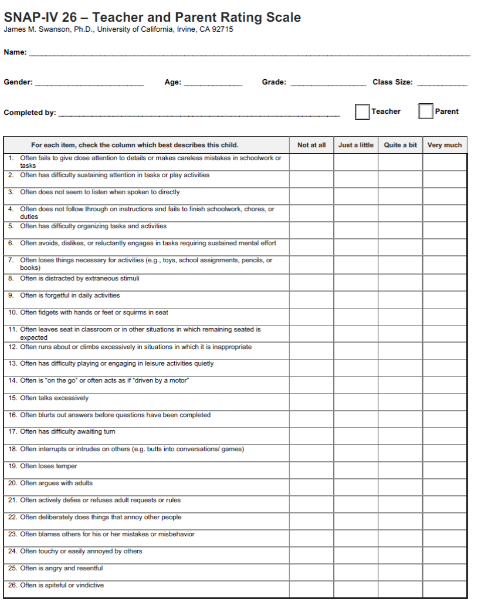

WEISS Functional Impairment Scale
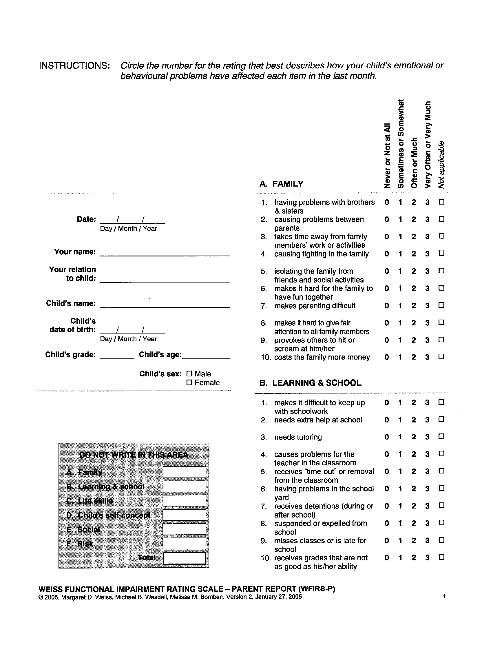

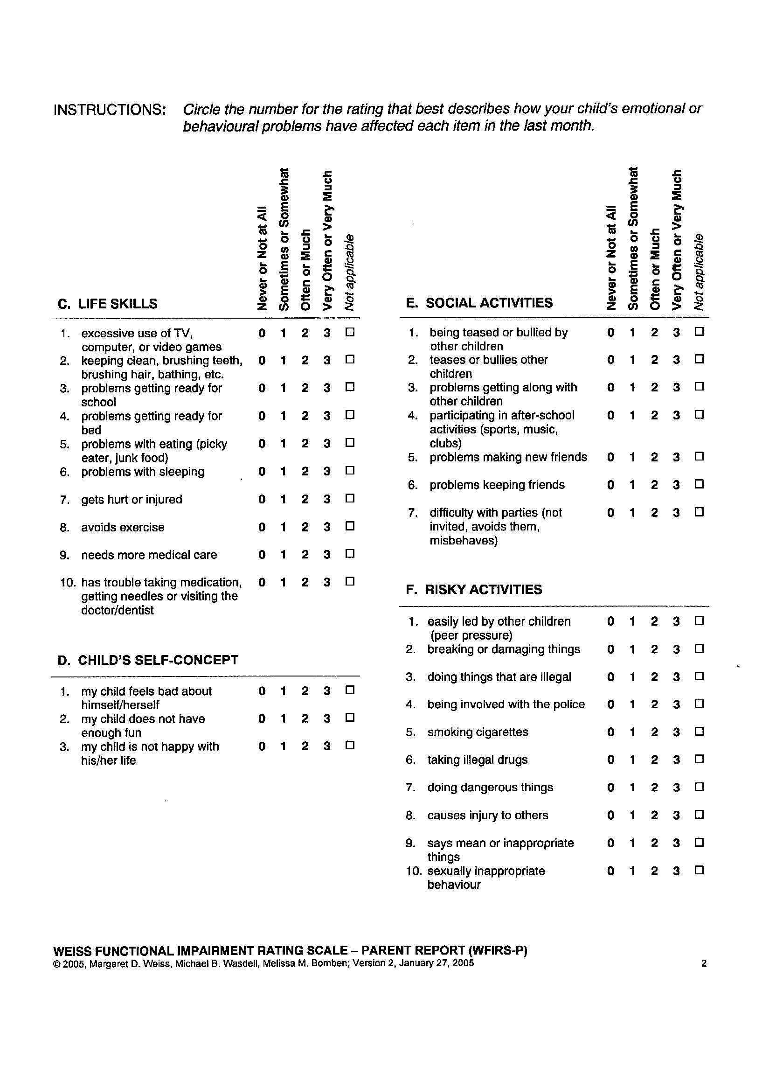
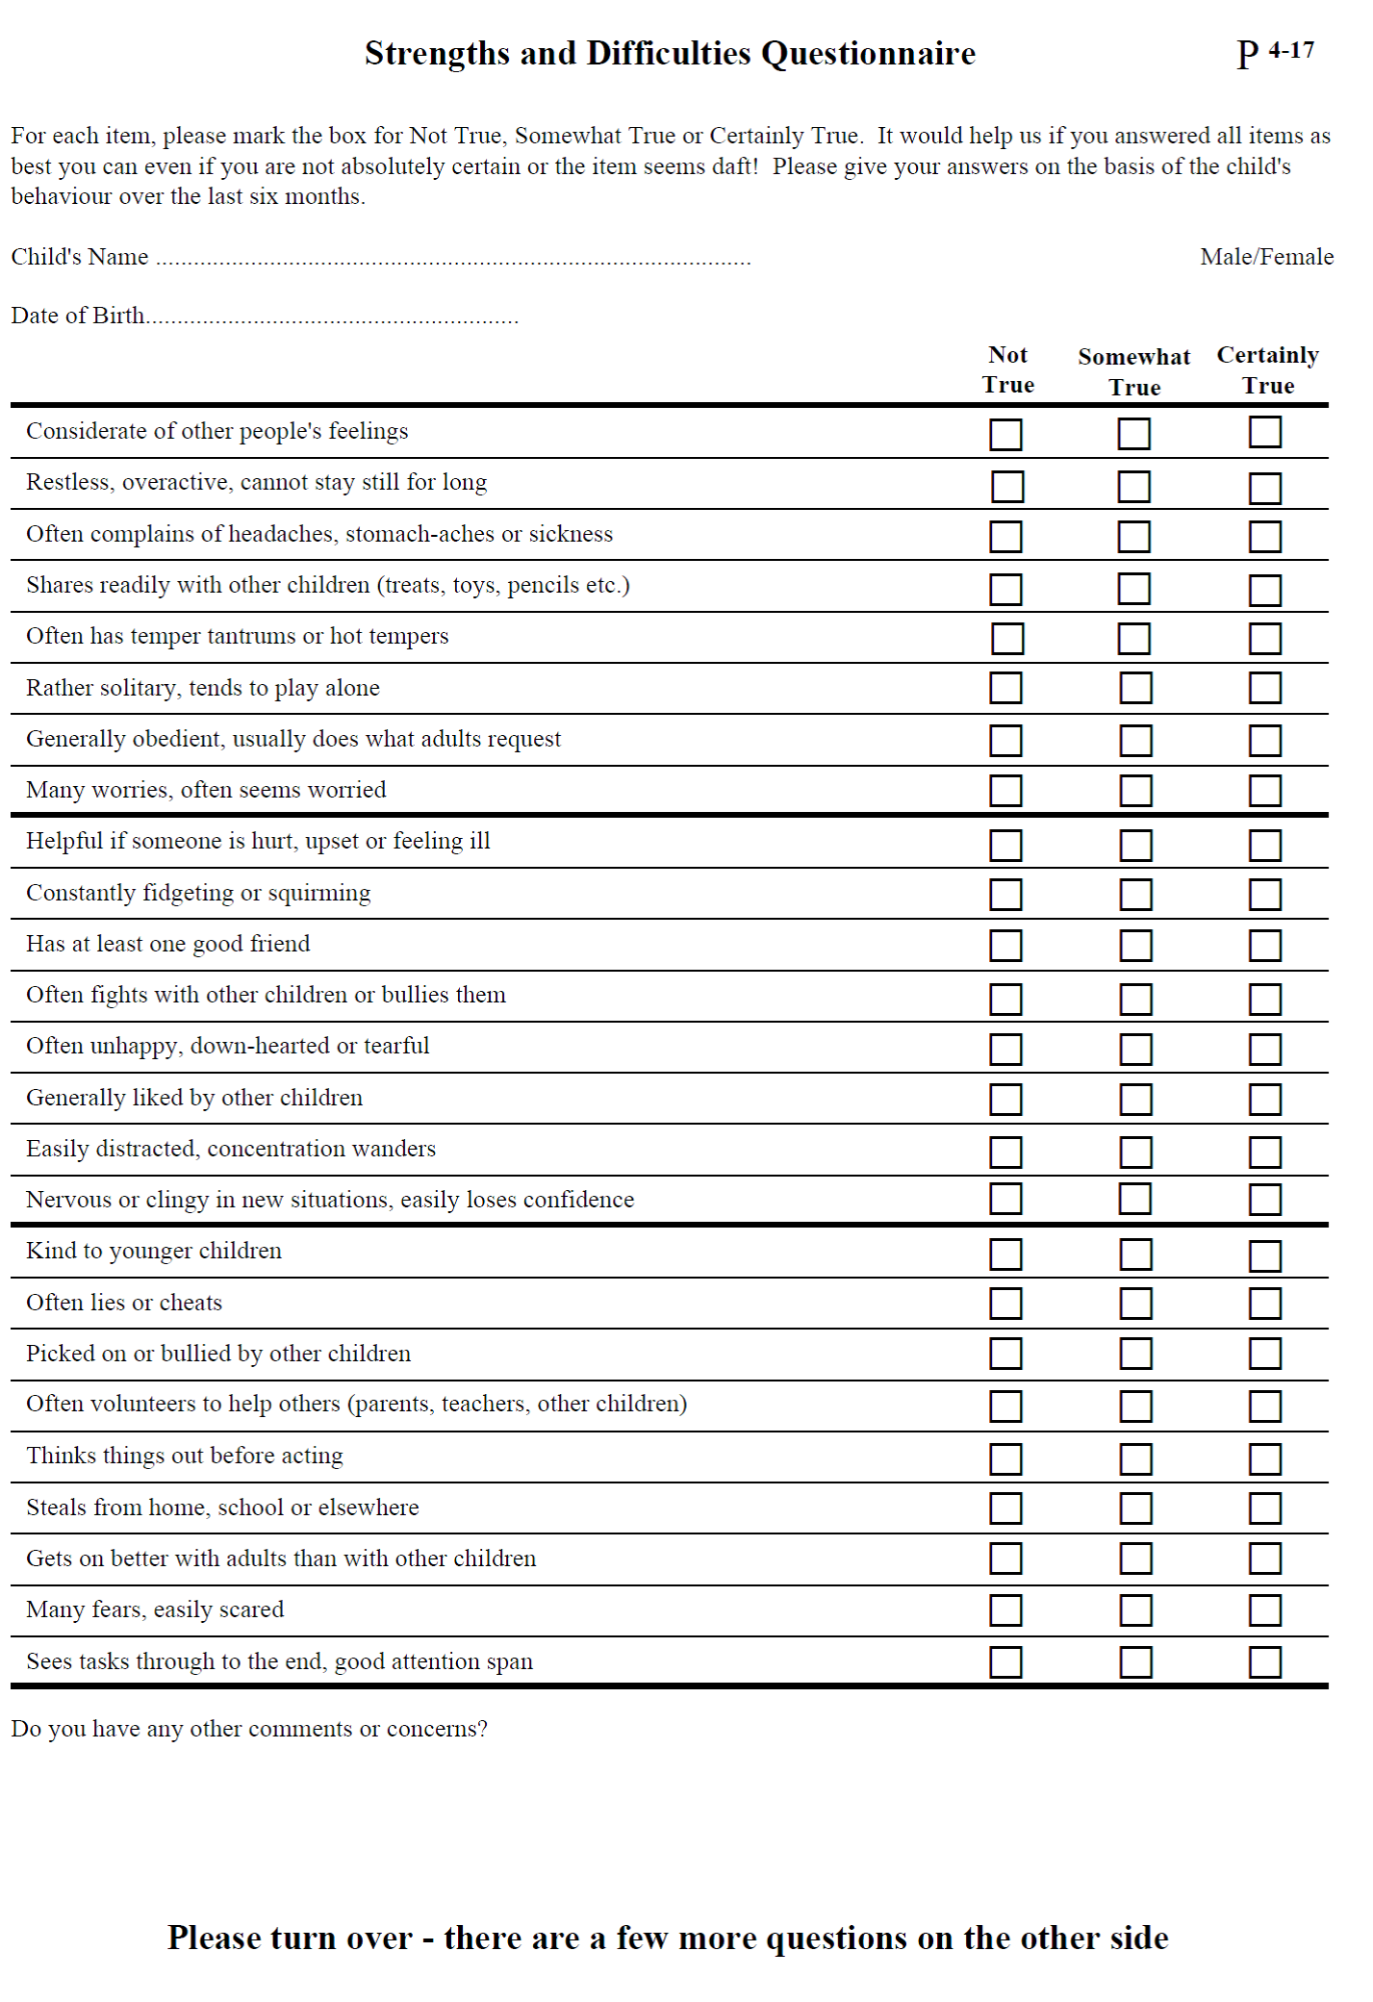
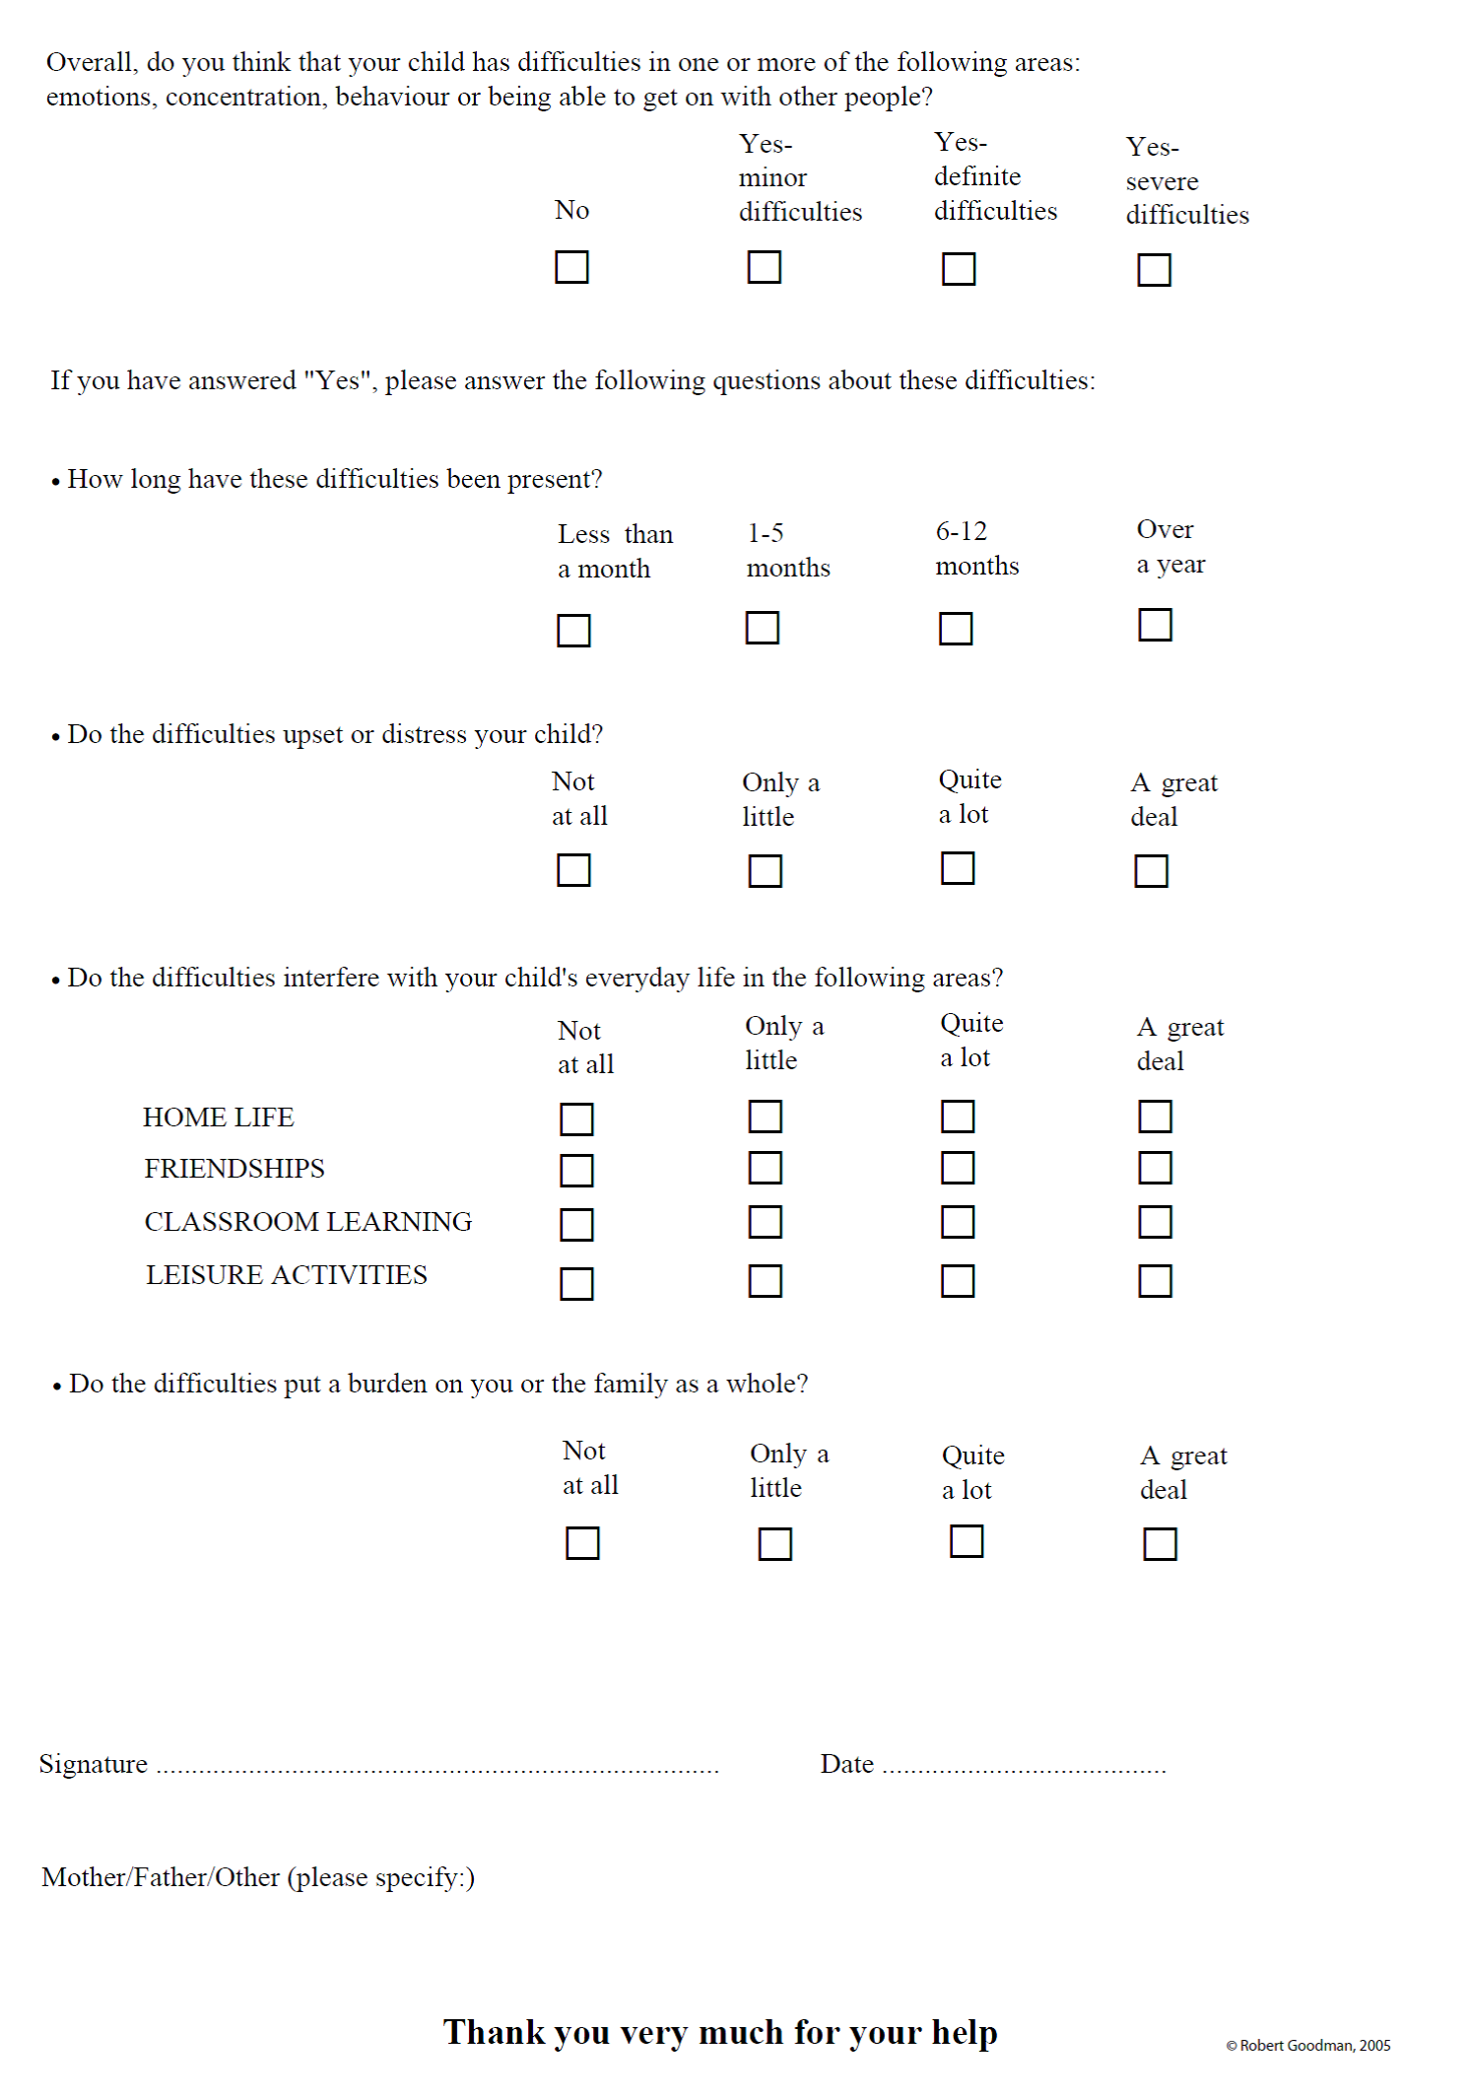
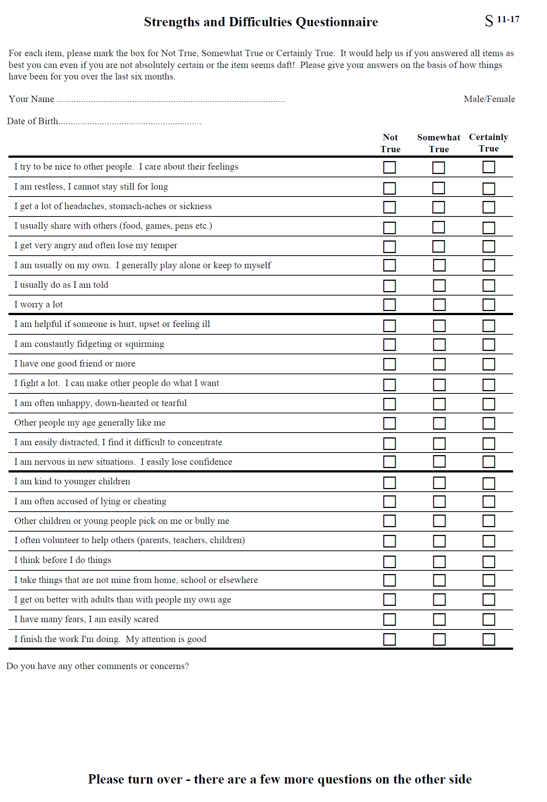 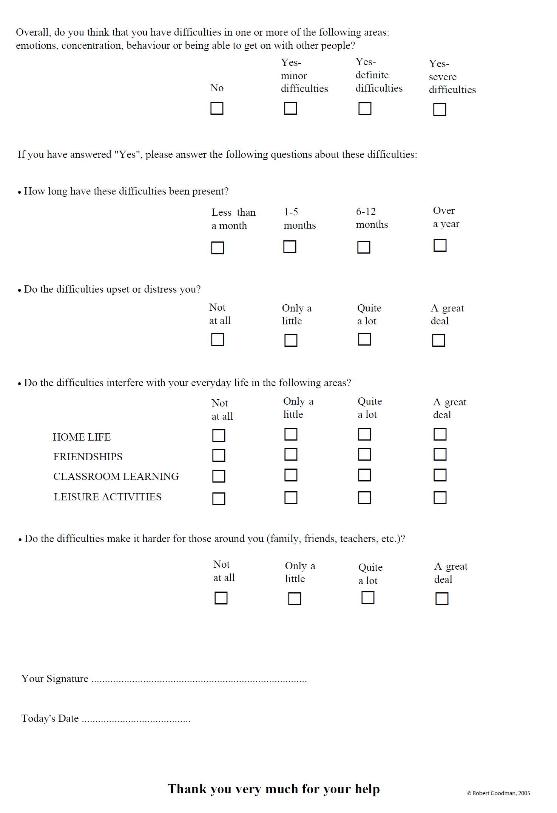Acknowledgement: This assessment has been developed by members of the East and North Hertfordshire NHS Trust ADHD Team.

