
tors
Practice Leaflet
“We strive to provide the highest standard of care available; we work to empower our patients to manage their own health.”

Doctors
Dr Rachel Jameson  Dr Ivar Claros  Dr Harriet Goodhead  Dr Amanda Nicholls | Dr Edward Ford  Dr Antonia Gowan  Dr Tahera Kamal  Dr Nisham Ghimire | Dr Arabella Sargent  Dr Caroline Densham  Dr James Botham

Medical Practice Opening Times
Monday to Friday 8:00am - 6:30pm

Contact
Tel: 01243 608201

We hope you find the information contained in our practice leaflet useful.
Further information, along with links to services and self help guides, can be found on our website:

Website: www.selseymedicalpractice.co.uk

Please note that Selsey Medical Practice operates a zero tolerance policy to aggressive and abusive behaviour.

New Patients

Registration
If you are new to the area and wish to register please visit our website or ask at reception.

A “new patient check” is available for all our newly registered patients; this can be booked at reception.

Allocation of a named GP
All patients are allocated a named GP who is administratively responsible for their overall care at the practice. If you wish to know who your named GP is please contact the practice. If you have a preference as to which GP this is, the practice will make reasonable efforts to accommodate your request.



Self Care

Self care helps us to help everyone better:
Many minor ailments can be treated at home and we would like to urge our patients to consider self-care first, where appropriate, in order to leave more appointments for patients who need them. Please find below a list of ailments you may be able to safely manage yourself:

Back pain | Cold sores | Common cold
Conjunctivitis | Constipation | Diarrhoea
Earache | Haemorrhoids | Hay fever
Head lice | Headache | Influenza
Insect bites | Migraine | Period pain
Nasal congestion | Nappy rash | Sore throat
Sinusitis | Sprains & Strains | Thrush
There are other conditions that can be managed at home if they are not related to any other underlying conditions, for example: a cough that doesn’t last for more than three weeks, heartburn & indigestion unless symptoms persist.

Still not sure what to do?
There is plenty of useful information on the Internet, for example:

- www.nhs.uk
- www.patient.co.uk
- www.selfcareforum.org

You can also get great advice and treatment for some common minor conditions from your local pharmacy.


Appointments
The practice uses a total triage system. Patients submit an online form via our website or the NHSApp which is triaged by our clinical team, you will then either be offered an appointment with a suitable clinician or offered advice as to how to access other appropriate services. If you are unable to complete the form yourself, the patient services team will complete it with you.

Getting the most from your appointment
Unless otherwise specified, an appointment normally lasts for 15 minutes which is only enough time to discuss one medical problem.
If you have more than one problem to discuss, we will make every effort to book a longer appointment.

Before your appointment:
- Clearly formulate in your own mind what you are worried about and highlight any particular concerns.
- Consider preparing short notes to help you remember what you want to say including a description of your symptoms and exactly how long they have been experienced (in days, weeks or months)
- Consider what is achievable in your one appointment. Be realistic.
- Get to the point. You do not have to justify being there and don’t save important issues to the end when you’ve run out of time.
- Wear easily removed clothing if you think you may need to be examined.
- At the end of your appointment, make sure you fully understand any advice you’ve been given or steps you must take.
- Don’t be put off by a doctor or nurse running late. This is often due to them having to give bad news to a previous patient or dealing with an emergency before you arrived. Many of us might unexpectedly require a bit of extra time one day so although it might not be convenient to you, please consider others.

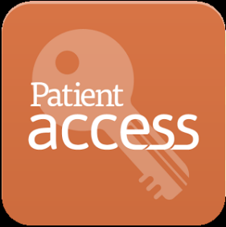
Online services
Signing up to online patient services can make your life much easier at the same time as helping us to be more efficient. You can access these services via a computer, smartphone or tablet. The NHS App can be downloaded on to your smartphone or tablet and can be accessed via a web browser.

Here are some of the things you can do through the NHSApp:

Access your GP online Triage service
Once you have linked the NHSApp to our GP practice, you can access the online consultation service.

Ordering Repeat Medication
All of your repeat medications will already be listed and all you have to do is click on the items you want. It really couldn’t be simpler. The best thing is that your request arrives into our computer system immediately and is usually dealt with more quickly as a result.

Access your Medical Records
If requested, patients can also have access to their medical records including test results.

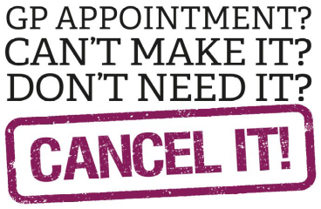
Practice Policies

Cancellation policy
Please give us at least 24 hours’ notice of any cancellations. You can cancel your appointment online or via our cancellation line (01243) 608201 option 4.

Missed appointments
Unfortunately we see too many appointments wasted by patients not turning up. We realise that everyone can make mistakes and so we won’t take any action if a single appointment is missed in error.

Where more than one appointment is missed in a twelve-month period the Practice Partners reserve the right to consider what action might be taken, including removal of the patient from the Practice's list.

Home visits
Home visits should only be requested for those who are unable to come to the Surgery because of serious illness and infirmity. Visits are for medical, not social or personal reasons. Visits should be requested before 11am.

Whenever possible we prefer to see you at the Surgery; if you do not feel well enough to sit in the waiting room we can make alternative arrangements.

It is always better to be seen in a fully equipped GP surgery with proper lighting, examination equipment and access to tests.

Chaperones
All patients are entitled to have a chaperone present for any consultation. Please request this at the time of booking or speak to your GP.

Teaching
As an accredited training practice we regularly have medical students spending part of their training with us. We also have Registrars with us. Registrars are qualified doctors in their last year of specialty GP training.

Disabled access
The surgery has designated parking spaces, wheelchair access, lift and toilet facilities.

Data protection
All information held about patients is completely confidential. For details of how we manage and use your information please visit our website.

The Freedom of Information Act
The Freedom of Information Act gives you the right to request information held by a public sector organisation. There may be a charge for this information.

Out of Hours & other services in the area

NHS111

Open 24/7 - Just dial 111
When the practice is closed (before 8.00am or after 6.30pm weekdays and at weekends) you can call NHS 111 for help and advice. The call is free from any phone including mobiles and you simply dial 111. This provides access to medically trained staff that will be able to provide advice on self-care, or tell you where you can go to get treatment. They can also arrange an urgent appointment at a 24-hour GP service or even a home visit.

Minor Injuries Unit at Bognor War Memorial Hospital
Shripney Road, Bognor. 01243 623563
Anyone can use this walk-in service: you do not need to be a registered patient here. The walk-in service offers treatment, information and advice for a range of minor injuries. It is open 9:00am-5:00pm Monday - Friday.

Emergencies
If you have a life-threatening emergency at any time please call 999.
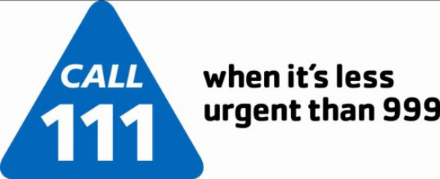

Prescriptions

Requests
We require 4 working days’ notice to issue repeat prescriptions. Your chosen pharmacy may need an additional 2 days to prepare your medications. Most patients will know exactly when their medications will run out, so please plan for it and give us the minimum 4 days’ notice. PLEASE NOTE TO AVOID ERRORS WE DO NOT TAKE PRESCRIPTION REQUESTS OVER THE TELEPHONE.

Repeat prescriptions
Repeat prescriptions can be ordered in a number of different ways:
- You can place your order using the online service (via our website)
- You can use the NHS App.
- By dropping off your request to the surgery in the form of a letter or note
- By dropping off your white ‘tick box’ form, which is attached to all of your prescriptions. These can be deposited in the left hand side enquiries desk.

Practice/Patient relationships


Zero tolerance policy
Selsey Medical Practice operates a zero tolerance policy to all and any abuse towards its staff, doctors or other patients. This could be physical, verbal or online abuse.

All our staff aim to be polite, helpful, and sensitive to all patients’ individual needs and circumstances. We would respectfully remind patients that very often staff could be confronted with a multitude of varying and sometimes difficult tasks and situations, all at the same time. Aggressive behaviour, be it physical, verbal or online, will not be tolerated and may result in you being removed from the practice list and, in extreme cases, the Police being contacted.
In order for the practice to maintain good relations with our patients we would like to ask all our patients to read and take note of the types of behaviour that would be found unacceptable:

- Using bad language, swearing or shouting at practice staff.
- Any physical violence towards any member of our team or other patients.
- Verbal abuse towards the staff in any form including shouting.
- Racial abuse, discrimination or sexual harassment will not be tolerated.
- Persistent or unrealistic demands that cause stress to staff will not be accepted. Requests will be met wherever possible and explanations given when they cannot be met.
- Being perceived to bully a staff member to obtain something.
- Causing damage/stealing from the practice's premises, staff or patients.
- Obtaining drugs and/or medical services fraudulently.

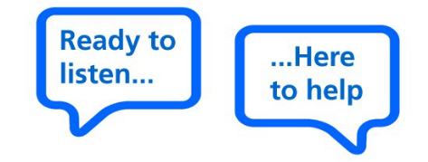
Compliments, suggestions and complaints
The staff of Selsey Medical Practice seek to provide an excellent service to their patients. We do recognise that things don’t always go to plan and on those occasions, we would like to hear about them so that we can investigate and make any changes necessary.

If you wish to give feedback (positive or negative) or make a formal complaint, please ask to speak to a member of the team. Please note that we keep strictly to the rules of medical confidentiality. If you are complaining on behalf of someone else, we must have their written permission for your to do so. A letter of consent signed by the person concerned will be needed, unless they are not able to provide this.

We have a dedicated complaints leaflet, which can be found on our website and can be provided to patients on request. This contains more detailed information including where you can go if you feel that your complaint has not been resolved to your satisfaction.

Health service advocacy
If you need help and advice in respect of health and social care services, support with a complaint against an NHS funded service, or you wish to share your experience, you can contact Healthwatch Sussex:

By phone on 0300 012 0122,
Or by email helpdesk@healthwatchwestsussex.co.uk
Or in writing to Healthwatch West Sussex,
C/O Help & Care
A49 Aerodrome Studios
Christchurch
Dorset
BH23 3TS

Patient Group
We have an active Patient Group. All members are patients and we value their opinions. If you would like to join the group pick up a leaflet from the surgery or online.

Friends Of Selsey Medical Practice
“Friends of Selsey Medical Practice” raise money for vital equipment for our patients. If you would like to join Friends of Selsey Medical Practice pick up a leaflet from the surgery or online.

Updated October 2026

